LAB 3: DESIGN SPRINT EXPERIMENT REPORT
Scenario: Citizens Face Delays in Government Service Approvals

1.Aim of the Experiment
The aim of this experiment is to apply the Design Sprint methodology (Empathize, Define, Ideate, Prototype, and Test) to design a user-centered solution for citizens experiencing delays in government service approvals such as licenses, certificates, and permits. The focus is on understanding real citizen challenges and validating solutions through feedback.

2.Problem Context
Citizens often face long delays while applying for government services such as:
- Birth and income certificates
- Driving licenses
- Building permits
- Pension approvals
- Land record verification
These delays happen due to:
- Manual paperwork
- Lack of status transparency
- Multiple departmental approvals
- Poor communication
- Staff shortages
This results in:
- Wasted time
- Multiple office visits
- Financial loss
Frustration and stress
Reduced trust in government systems

3.Empathize Stage
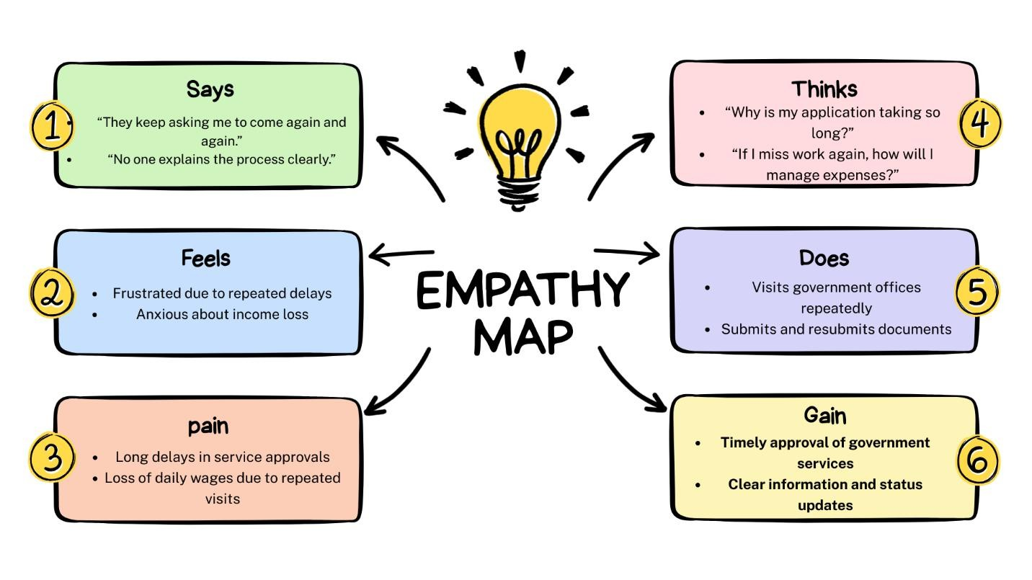
Objective:
To understand the needs, frustrations, and experiences of citizens facing approval delays.
Activities Performed:
- Interviewed 3 citizens who applied for certificates and licenses
- Observed long waiting queues at local government offices
- Collected feedback about online portal experiences
Key Observations:
- Citizens are unaware of application status.
- They must visit offices repeatedly for updates.
- Documents are sometimes misplaced.
- No clear timeline is provided.
User Insight:
Citizens need a transparent and trackable system that clearly shows the approval status and expected completion time.

4.Define Stage
Objective:
To clearly define the core problem.
Problem Statement:
Citizens need a transparent and efficient way to track government service approvals because delays and lack of communication cause frustration and inconvenience.
How Might We (HMW) Question:
How might we create a transparent system that reduces delays and keeps citizens informed about their application status?

5.Ideate Stage
Objective:
To generate multiple possible solutions.
Brainstormed Ideas:
- Real-time Application Tracking System
- SMS and Email Status Updates
- Digital Document Verification System
- Online Appointment Booking
- Single-Window Approval System
- Escalation Option for Delayed Applications
- Citizen Dashboard with Timeline Tracker
Idea Selection:
Selected Idea: Smart Government Service Tracking Portal
Justification:

Improves transparency
Reduces unnecessary office visits
Easy to implement digitally
Enhances citizen satisfaction

6.Prototype Stage
Objective:
To create a low-fidelity prototype of the solution.
Prototype Description:
Home Dashboard Screen:
- Application ID
- Current Status (Pending / Under Review / Approved)
- Expected Approval Date Timeline View Screen:
- Step-by-step approval progress
- Department responsible for each step
Notification Screen:
- SMS/email alerts
- Delay notifications Escalation Feature:
- “Report Delay” button
- Direct complaint submission option Design Rationale:
- Simple layout for easy understanding
- Visual progress bar improves clarity
- Notifications reduce uncertainty
- Escalation option increases accountability
Prototype Type:
Low-fidelity paper wireframes / basic digital mock-up
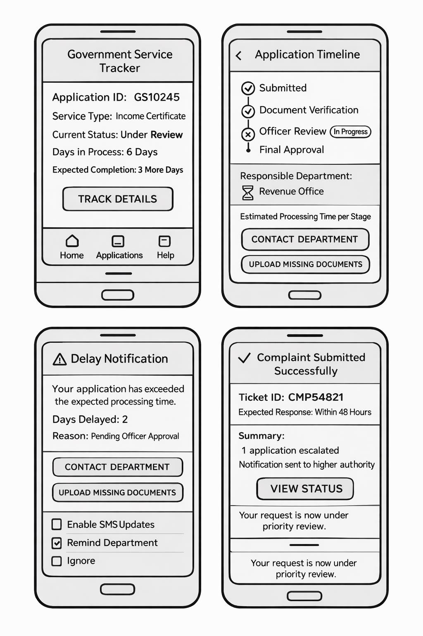

Test Stage
Objective:
To test the prototype with users and collect feedback.
Testing Method:
The prototype was shown to:
- A college student applying for a caste certificate
A small business owner applying for a trade license
A senior citizen applying for pension approval
They were asked to check application status and simulate reporting a delay.

7.User Feedback Summary
User 1 (College Student):
Found the tracking system very helpful. Suggested adding a document upload reminder.
User 2 (Business Owner):
Liked the timeline view but requested estimated processing days for each stage.
User 3 (Senior Citizen):
Appreciated SMS updates but suggested adding a simple language option for better understanding.

8.Observations
- All users preferred online tracking over physical visits.
- Users wanted clear deadlines.
- Transparency reduced anxiety.
- Simple design improved usability.

9.Iteration and Improvements
Based on feedback:
- Add regional language support
- Include estimated processing time per stage
- Add document verification checklist
- Provide help chatbot support

10.Reflection
This experiment revealed that the main issue is not only delay but also lack of transparency and communication. Citizens feel stressed because they do not know what is happening with their applications.
The Design Sprint process helped in understanding real problems and refining the solution based on feedback instead of assumptions.

11.Conclusion
The Design Sprint methodology effectively helped design a transparent Government Service Tracking System to reduce delays and improve communication.
By focusing on empathy and user feedback, a practical and citizen-friendly solution was developed that can improve trust, efficiency, and satisfaction in government service approvals.

Name : Nayana Naik
Roll no : 24BEIS106

